**Introduction to “Lunetta” CMOS Synths**



Written and compiled by Sergio Gonzalez

Is there anything that you have come here to find that is not here?

Is there anything that you were looking for that this document failed to deliver?

**Please tell me about it:** [**droffset13@gmail.com**](mailto:droffset13@gmail.com)

**Acknowledgements**

**Introduction**

**Community**

**What is a Lunetta CMOS Synth?**

**The format of this eBook:**

**What is “in The Lunetta Spirit “?**

**See more examples:**

**Hear Some Examples**

**About Stanley Lunetta**

**This is a description of Stanley’s Moosack machine written by Stanley himself.**

**Overview of digital logic and square waves.**

**Integrated Circuits**

**Put in a description of what an integrated circuit is and why they are desirable.**

**How to think about CMOS ICs(And integrated circuits in general.)**

**WHAT ABOUT ALL THE OTHER CHIPS?**

**Why CMOS?**

**What about OpAmps?**

**Skills and knowledge you'll need**

**Equipment you'll find useful**

**OK... BUT WHAT DO I BUY?**

**Building one - Start Here**

**The first tutorials you should do:**

**Got something working?  Show it off at the beginners thread!**

**Building Blocks**

**Your Power Supply**

**Community comments about power supplies:**

**LEDs**

**Decoupling Capacitors**

**Pull Down Resistors**

**Oscillators**

**DIVIDERS**

**Logic Gates**

**Shift Registers**

**PITCH MAKERS**

**More Block Ideas**

**NOISE (white/pink/etc)**

**Mixers**

**Your first patches**

**Illustrate each patch, and have a sound clip**

**Moving off the breadboard – and onto panels!**

**Things to consider when designing a Lunetta:**

**Lunetta Interconnect**

**Lunetta Construction Methods**

**How to Connect Lunetta Modules**

**Hooking up to your sound card with a Capacitor:**

**Getting advanced,**

**The Slacker Melody Generator**

**My standard starting point:**

**the R/2R DAC**

**Interfacing with other devices.**

**Stand alone projects that are Lunetta Friendly**

**NAND synth**

**WSG**

**Here's the thread that started it all.**

**Larger Projects to make (Let's DO THIS):**

**1. Lunetta in the style of a modular synthesizers**

**2. Single Board Lunetta**

**4. Les Hall's Boolean Sequencer**

**Lunettas and your modular synthesizer**

**Where to go from here?**

**Resources and credits**

**The most helpful link in the world.**

**Good Books**

**CMOS IC info**

**Other info**

**Contact me:**

# Acknowledgements

Thank you to everyone that has contributed to the document!

Thanks very much to anyone who comes to read this document, I’m so happy that people find it worthwhile, and I would very much like to get back into the swing of things, and this might actually happen in a couple of months.

If you have any suggestions on content to include, Comments are now enabled. Or feel free to get in touch at [droffset13@gmail.com](mailto:droffset13@gmail.com) .

# **Introduction**

Welcome to [the Lunetta forum at Electro-music.com](http://electro-music.com/forum/index.php?f=160) !  People around the web might call these machines Lunetta CMOS Synths, or CMOS synths, but around here we just call them Lunettas.  This tutorial is meant to be a guide to starting out with building these machines and get you having fun as soon as possible.

One of the first things that people get frustrated with when starting to learn about this is that no one can really give a good brief explanation of what the heck a Lunetta is let alone tell you how to build it.  That's because no two machines are exactly alike and the specific parts used  can be a pretty personal decision.

However, there are some common modules that almost everyone builds at first, so we'll go through those to get you started.  After using these blocks you'll probably understand enough to run with any CMOS datasheet you get a hold of.

## Community

I need community to stay interested in a topic. I need other people to bounce ideas with. Luckily we have a great DIY Synth community at: <http://electro-music.com/forum/forum-160.html>

Please stop by and say hello|!

## What is a Lunetta CMOS Synth?

-Some people see it as the next step after circuit bending.

-Some people call it the next step after building the Atari Punk Console

-Some people see them as crazy gate sequencers

-Some people use the digital data and convert it to analog to run VCOs. (Voltage controlled oscillators)

-I call it the first step into DIY synth addiction.

What it isn't:

-It's not a device to reproduce/synthesize sounds from the natural world.

-It's not a perfectly tracking 1 volt per octave precision musical keyboard.

-It's also not very complicated.

It is what it is.  It makes cool sounds using a set of building blocks.

It's a node-based approach to building a complex system.

It's an educational tool because it is tactile. It is visual. You can develop tangible results and a great deal of understanding in a short amount of time.

It's fun because it's both simple and challenging and can make super cool sounds.

THE WHOLE POINT is to use whatever you can get your hands on in as simple a way as possible.

## The format of this eBook:

This document is meant to collect the knowledge gained from extensive collaborative exploration by the people of the Electro-music.com forums. Most of the time there is one post on a given topic that summarizes the concept that I am referring to, but quite often there is a lot of useful information in the various posts discussing the problem that lead up to the solution. Because of this I will often mention a topic and then provide a link to the most relevant forum post I can find.

Another key idea is that there has been quite a bit of work done by members of the wider DIY synth community that include tutorials on building CMOS-based synths. Time is short these days, so instead of recreating the tutorial in my own words I will often link directly to their web page while giving an explanation as to why that page is relevant. Since we am not aiming to profit from this eBook I am fine with you travelling to someone else’s page. We do hope that you come back.

## What is “in The Lunetta Spirit “?

This is a way to start exploring and playing with electronics and synths for people who want to approach it with an open mind. As you progress in this you might want to use something other than what is recommended. Please do, and let us know how it goes. Who knows, your idea might help someone else have an easier time learning.

You don’t have to worry about your machine being ‘pure.’ Just keep it simple (or not) and let it take you wherever makes sense. Stanley Lunetta’s first machines were made in this way because he was simply using what he had access to. We’ll provide suggestions based on experience, but experimentation is the only rule.

Let's see some examples.

**Examples**

Have you ever seen one of those 130-in-1 electronics kits?  Each component on the board has springs that you can connect with wires?  Most of these will include at least one digital IC, usually a NAND gate.

Can you spot the NAND gates in this image?  Can you identify the various components mounted to this panel?

<http://sciencestore.co.uk/acatalog/EK1102L.jpg>

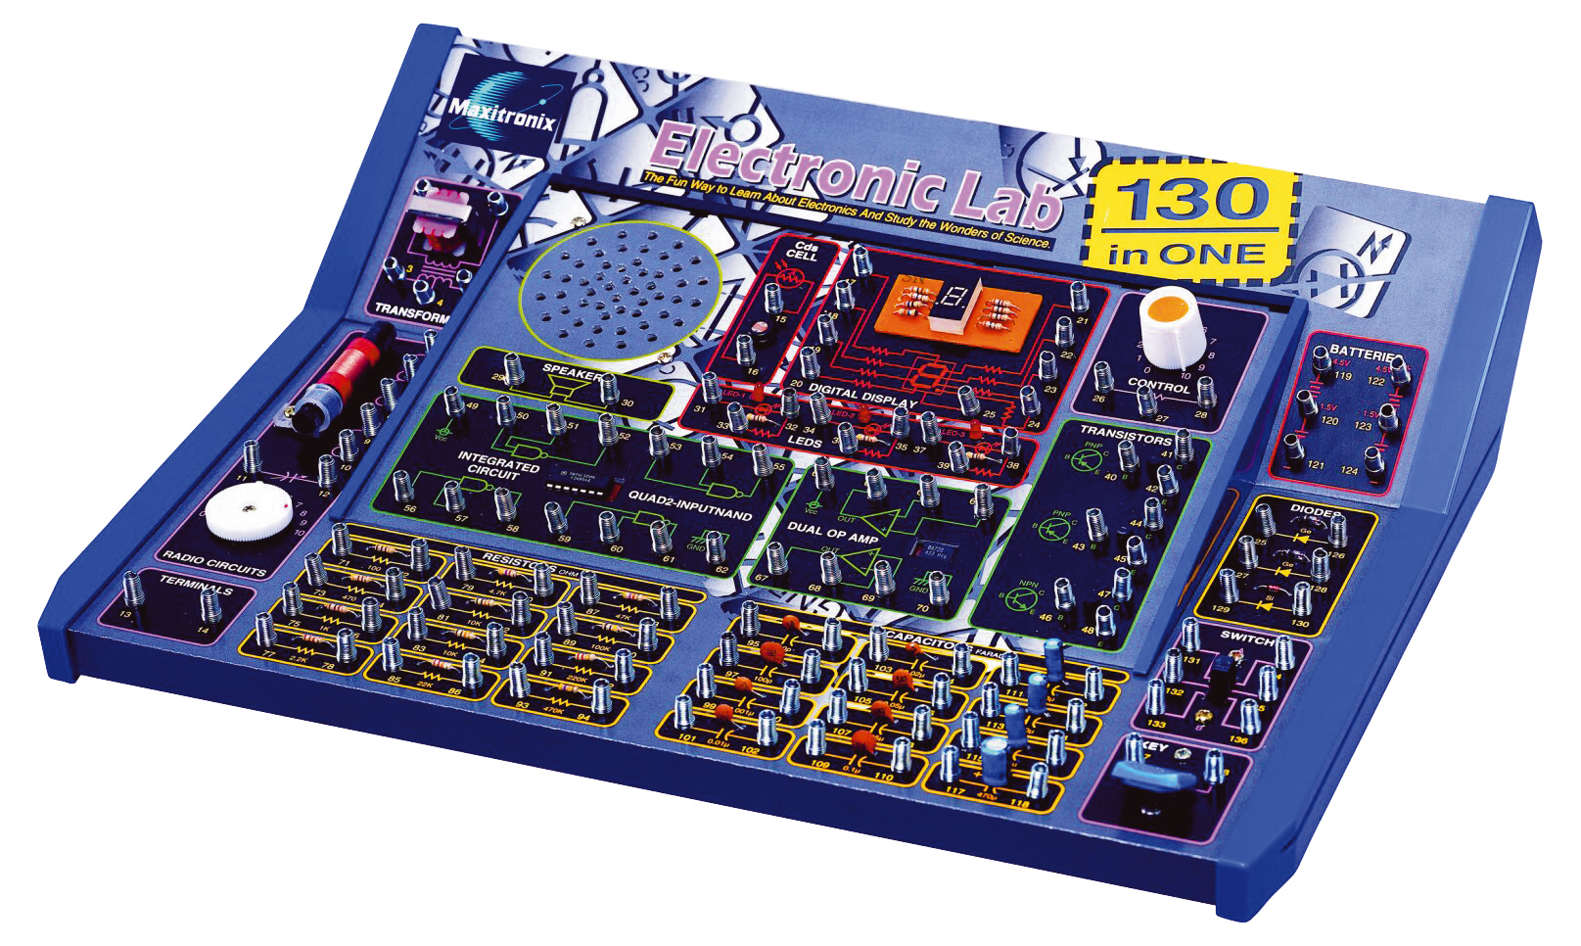

You could say that this item is in the spirit of what we're doing.  Components with their connectors directly wired to a panel or interface.  Very flexible, very quick to get ideas going.  In fact, I still have my 130-in-1 lab and use it in my Lunetta, there are a lot of useful things on that panel!

A Lunetta is the same basic concept, the pins of the ICs are connected directly to panel jacks that you can connect together using wires.  Some people use alligator clips to connect them, some people use banana jacks, but it's all the same.

Here's a picture of Mosc's machine from way back when.

<http://electro-music.com/forum/phpbb-files/thumbs/t_lunetta_163.jpg>

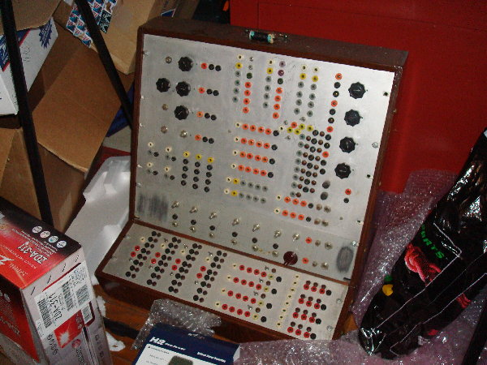

Here's one that Stanley himself built. <http://moosack.net/cube.jpg>

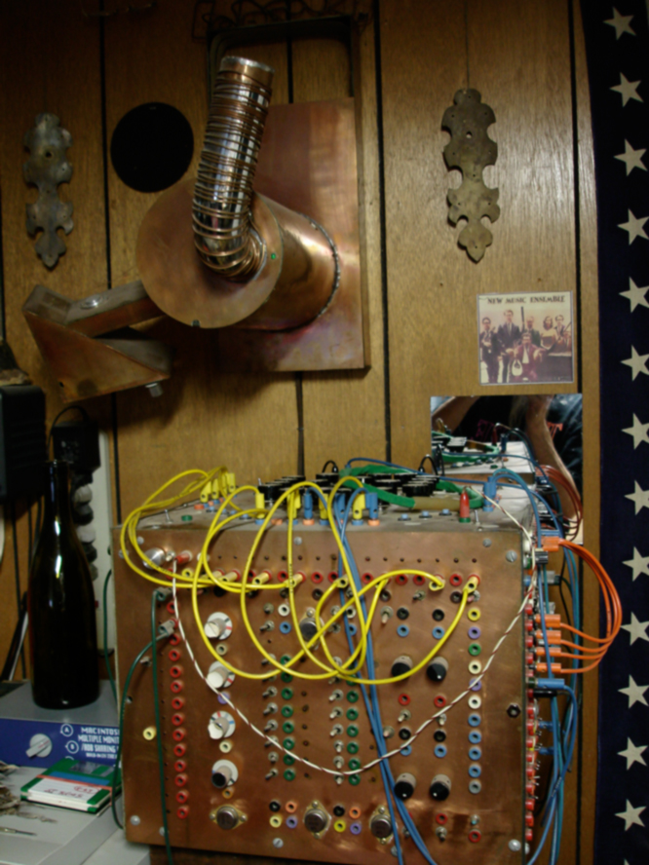

Here is one that I built: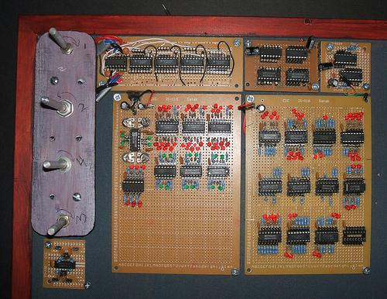

Don’t get intimidated with these crazy looking things.  Inside is just digital chips, and each of the pins of the chips is connected to one of those jacks.

That's really the whole point.  Learning what the different types of logic chips do, and making use of them in interesting ways.

Want to build one?  You're brave, read on!

## 

## See more examples:

Click the link to check out the machines built at Electro-Music.com !

<http://electro-music.com/forum/topic-30479.html>

Check out the beginner's thread!

<http://electro-music.com/forum/viewtopic.php?t=42357>

This is a fantastic Modular style build:

<http://dlbelectronics.com/lunetta>

## Hear Some Examples

Here is a link to my Soundcloud account where I have a lot of examples:

<https://soundcloud.com/droffset>

Les Hall used to do a great radio show on radio.electro-music.com.  He has done shows on a variety of topics and here we can find an MP3 of his Lunetta Show.

<http://electro-music.com/forum/viewtopic.php?t=36130>

# **A**bout **S**tanley **L**unetta

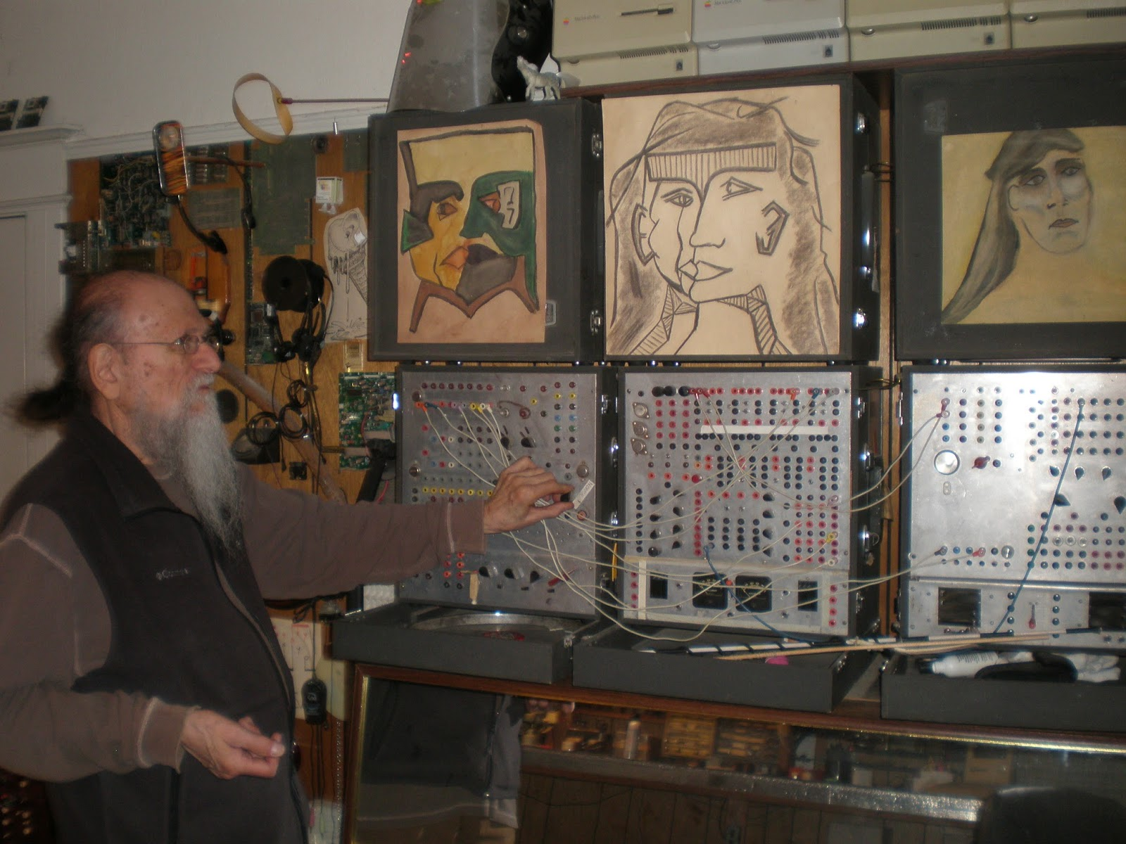

Stan is an artist.  <http://moosack.net/stang/modules.html>

**Quoting Mosc**: “I've gotten requests to go into depth on the little cheap simple digital synths called Lunettas. These machines are named after Stanley Lunetta of Sacramento, California. Stan informally taught a few of us how to build these things in the early 1970s. He was an inspiring teacher, to say the least. He never liked us calling these things Lunettas, but, Stan, you don't always get what you want. We call these Lunettas as an homage to a great man, a creative inspiration to me and many others.

Lunettas are very simple, digital, noisy, quirky, and lots of fun. Forget the analog synth model - no VCOs, filters, ADSRs, and that stuff. In some way, these aren't synthesizers because they aren't designed to synthesize any sounds. They are certainly electronic musical instruments. “

He's known as sTANg  on the EM forums, here's a thread where he shares some of this stuff:

<http://electro-music.com/forum/viewtopic.php?t=38352>

# This is a description of Stanley’s Moosack machine written by Stanley himself.

Stanley Lunetta   
Moosack Machine   
March 7 - April 19, 1970   
  
The moosack machine is a sculpture that produces, mixes and processes electronic sound. In the present version, the machine routes these sounds to four speakers placed in four corners of a room, and also to an audio transducer contained in the sculpture in the center of the room.   
  
The moosack machine has two parts. The first, completely contained in the sculpture, consists of four variable oscilators, two power regulators, and a large number of input sensors. The input sensors detect changes in light, temperature, wind direction ands well as movements of people around the sculpture. These components are assembled as a sculpture, using the resistors, capacitors wires, etc. for their appearance as well as for their various electronic functions.   
  
The second part of the moosack machine contains four mixers, the fixed oscillator/frequency divider unit, the relay box, the digital logic system, plus filters, phase shifters and reverb/tape-echo units.   
  
The variable oscillators, controlled by the input sensors produce constantly changing output signals; e.g., continuously variable sweeps and/or disjunct leaps in either direction, amplitude, and time-event changes, and off/on functions. The output of each variable oscillator is mixed with one of the outputs from the fixed ocillator/frequency-divider unit and is sent to the digital logic system.   
  
The digital logic system consists of a 16-bit digital counter/decoder, modified to have four inputs and eight outputs. Each output will function only when the inputs are in specific states. For example, output X1 will function only when the outputs of oscillators A, B and D are positive, and oscillator C is negative. Further, the four fixed oscillator/frequency-divider outputs (A,B,C,D) must also be positive-positive-negative-positive, if the output is to function. The fixed oscillator/frequency-divider unit moves from positive to negative at a very slow rate, changing its state one to three times per minute. Thus, the output of the digital unit consists of the relationships between variable and fixed oscillators.   
  
Through the relay box, the four outputs of the digital unit have control over the on/off functions of the electric motors in the sculpture, turning the "cut-out wheels" and affecting the light-sensitive input sensors. There are also photo-cells that override the X outputs, turning off the relays.   
  
The four Y outputs of the digital unit are used as audio outputs and are, of course, square waves. Thses outputs are either filtered, phase shifted, sent throuogh reverb/tape-echo units or frequency divided. The resulting sounds are then heard through the four amplifier/speaker channels. The fifth channel, a transducer in the sculpture itself, is taken from one of the mixers before the signal is sent to the digital logic system. Ideally. the moosack machine should be activated in the morning and allowed to play through the afternoon. The only human control over the moosack machine is the on/off switch. The recording in this issue was not edited or "composed" in any way. The moosack machine was allowed to play for 23 minutes. The record contains activities from the third to the eighteenth minute.

# Overview of digital logic and square waves.

Now that we know a bit more about the man, let's learn a bit more about the machine.

There is some foundation knowledge you'll need to grasp.

There is a difference between analog circuit and digital circuits.  Lets say you have a circuit that runs on 9 volts.  An analog circuit can make use of all the voltage values between 0 and 9v to do its work.  A digital circuit works differently because it only recognizes two states, full voltage and no voltage.

Digital logic is generally discussed using terms like:

- High and Low

- 1 and 0

- True and false

- Full Voltage and No Voltage

- Rail to Rail

- Square waves

A Lunetta 's main tool is the square wave.

This is what a square wave looks like:

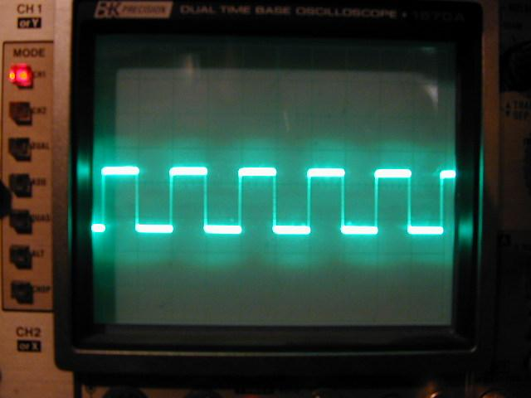

A Square wave can be called a digital function, since it's going 1,0,1,0, over and over again.

A Square wave can be used as a CLOCK, providing a timing reference like a heartbeat that the rest of a circuit will base its actions on.

A square wave can be a musical tone if you use it at a high enough frequency, with the pitch determined by its frequency.

# Integrated Circuits

### Put in a description of what an integrated circuit is and why they are desirable.

We  have a variety of ICs that are great for creating oscillators, which will generate square waves for us to mess with and do interesting things.

For example:

A 40106 IC can make 6 square wave oscillators with some added components. Others can too, but 40106 is very popular because it's easy to use.

A 4093 IC can make 4 square wave oscillators.

A 4060 has a built in oscillator with some nice surprises.

A 4046 has a very interesting set of tools including a voltage controlled oscillator.

## How to think about CMOS ICs(And integrated circuits in general.)

Each integrated circuit has inputs and outputs.

-Inputs (clock / data)

always connect all input pins to something, ground is a good start

types of inputs, clock input, data input, some can take analog signals.

-Outputs *(logic/analog)

What happens between the input and the output is a useful function.

-gate functions (NAND XOR etc)

-switching, analog and digital

-shift register - the more irregular the data going in, the more interesting the output will be.

-counter

-divider

## WHAT ABOUT ALL THE OTHER CHIPS?

The different CMOS ICs each have a function. You input something and something else gets spit out the other end. There might be more that one input and more than one output. The outputs can either change (modulate) the pitch (frequency) of an oscillator or the same output can be used as the clock reference for another IC.

A Lunetta machine, then, is a way to study how these different functions can interact.

Some ICs just count up to a certain number. The 4017 IC counts up to ten over and over again. The input is a clock, just a squarewave of a tempo that you choose, and there are ten outputs (0-9). So every time a clock ticks it'll step through each of the outputs and make it go High. People build sequencers with this.  Check out the “Baby 10”.

Some of them just add two signals together, some divide a signal by a certain amount(4040 is my favorite), some act as switches depending on whether the input is high or low. It can get really complex. In an Interview posted on this forum Stanley Lunetta described using the counter as the frequency base for a note's pitch. People have also converted the high/low outputs into a variable stepped voltage stream that can interact with a voltage controlled oscillator.

NOTE* I have a feeling that more illustration and explanation needs to go into explaining the concept of what an IC does, what do you think?

# 

## Why CMOS?

<http://electro-music.com/forum/topic-23876.html>

Why CMOS, and why the 4000 series?  Why not the 74XX series, or something else?

**QUOTE MOSC**

CMOS is the logical choice because:

CMOS is very forgiving to power supply ranges. Usually, you can use virtually any DC voltage source you have.

CMOS is low-power by nature. CMOS only uses power when the logic changes from one state to another. Since our circuits will usually clock at low frequencies (audio is very low frequency compared to usual logic rates).

TTL and others draw power constantly, so not a good choice.

The CMOS 4000 series is a good choice for standardizing because parts are cheap and readily available. 4000 logic can almost always work interchangeably with the 74C000 series, just in case. 4000 can also drive TTL in some cases as well.

Here is some great info on the 4000 series of chippies.

<http://en.wikipedia.org/wiki/List_of_4000_series_integrated_circuits>

<http://www.kpsec.freeuk.com/components/cmos.htm>

<http://electro-music.com/forum/topic-23968.html>

**Why not TTL?**

If you have access to TTL chips (namely the 74XX series) go for it.  It's ok.  But if you plan to you should be using a 5V power supply for the whole machine.  See the 5v regulator circuit.

I’ve added a 5V regulator circuit in a later section

Are there any rules to building these things?  What is properly in the "Lunetta Spirit?"

## What about OpAmps?

At some point you'll come across a circuit that looks useful and makes use of an Operational Amplifier.  Since Lunettas are all about experimentation, fun, and learning stuff, sure, try it out.

Let's try this as a general rule for opamps in Lunettas:  If you have at least a vague understanding of why you need an opamp and what purpose it serves and why a cmos chip can't do that, go for it.

What you should recognize though is that opamps are a different animal than cmos logic chips. They're analog and seem to turn up in output stages of circuits. Lunettas are digital creatures.  So while they'll be useful for lots of reasons it's recommended to try to focus on the cmos stuff for now.

But it’s your machine and your fun, so do whatever you like. Chase the knowledge, it’s fun.

Examples of op amp ICs are

LM386- you'll see small amplifier circuits using this a lot (The LM386 is a power amp rather than an op-amp -Mark Hadman)

741- general purpose op amp, the filter from the Weird Sound Generator uses this and is fantastic.  Find the WSG at musicfromouterspace.com (The 741 has poor response at high audio frequencies)

LM324- four op amps in one IC

TL074 - You'll see Les Hall use one of these for voltage followers. (The TL07x/TL08x family of op amps have very high impedance FET input stages, making them excellent buffers for separating different sections of an instrument.)

The opamps listed above can work on a single power supply, that's the positive voltage and ground.

Some opamps will require a dual supply, for example both plus and minus 9volts, and ground.  ICs like the TL0xx series are going to need that.  Eventually you're going to need that if you plan to keep going with this stuff.

# 

# Skills and knowledge you'll need

Reading a schematic

- Be able to identify what the various symbols mean.  Find some very simple schematics that you can build to practice the idea of thinking in terms of connections.

Identifying useful info on a datasheet

-When starting out you're just going to need to find the diagrams of what pins on the IC are meant to do what.  The first things you should look for are the power and ground pins.  Then try to identify the inputs and outputs.  Also look for information about what voltage the IC is looking for to operate.  Most of these ICs are going to allow a nice wide range of voltages.  Keep it between 5v and 9v for now.

helping yourself – how to search for info

## Equipment you'll find useful

-a small amplifier with a speaker

There are many free schematics available online.  I bought a kit from a shop called Jaycar electronics.  You might even be able to use basic powered computer speakers that have a volume control.

-a digital multimeter

Learn how to use the continuity tester.  Learn how to measure ohms to find a resistor's value.  Learn how to measure DC to test a battery to see how much juice it has left in it.

-a solderless breadboard and connector wire kit

    This is an essential tool for testing out ideas before committing to a soldered board.

# 

# 

# 

# OK... BUT WHAT DO I BUY?

The first Chips you should get

7805 5v regulator

40106 - hex schmitt trigger inverters

4011 - your basic NAND gate IC

4040 - divider/ripple counter

4093 - quad schmitt trigger NAND gates

4096 or 4024 (shift register)

4051 - multiplexer

4017 - decade counter

Get an amp, a simple 386 amp will do just fine, like the Little Ruby.

Maybe an audio jack or some cables to hook up to an amp or computer.

Passives

-Resistors - 1k, 10k, 100k,

-capacitors - get a variety pack if you can

Get some LEDs.

Potentiometers - 100k, 500k, 1M

# 

# 

# **Building one - Start Here**

Check out the beginner's thread!

<http://electro-music.com/forum/viewtopic.php?t=42357>

## 

## The first tutorials you should do:

There's already a wealth of free information on the web about creating sound with CMOS Ics, so instead of rewriting them I'll send you straight to them.

These sites will lead you through the basic concepts of creating digital oscillators and working with some basic chips.

Sebastian Tomczak's Fun with Sea-Moss

<http://milkcrate.com.au/_other/sea-moss/>

Bbob Drake's Electronoise Playshop

<http://www.fluxmonkey.com/electronoize.htm>

Building Tone Generators from CMOS Logic

<http://www.beavisaudio.com/Projects/CMOS_Synthesizers/>

Inventor's Radio Show tutorial

<http://electro-music.com/forum/viewtopic.php?t=38163&start=25>

Your first Ics, and general CMOS guidelines

-power supply - 5v is best

-inputs need to be connected to SOMETHING

-hooking up to an amp

-hooking up to computer sound card

# Got something working?  Show it off at the beginners thread!

<http://electro-music.com/forum/viewtopic.php?t=42357>

We want to see and hear what you've accomplished.  It doesn't matter how trivi[a](http://docs.google.com/Doc?docid=0AZIwOP-PR9sSZDlidzgzbV8wY3RjenJqanY&hl=en&pli=1#Top_of_Page_7631711854258393)l you think it is, just take a photo or even better, record some audio, and share it with the group.

You'll be glad you did.

# B**uilding Blocks**

## **Your Power Supply**

Not exactly the most glamorous way to start, but you need to sort out your power supply.  Start with a 9v battery snap that has tinned wires to connect with your breadboard.  That's fine.  Then as you go start considering a bit more permanent a solution.

Here is a schematic for a basic 5v regulator circuit that can be run on a 9v battery:

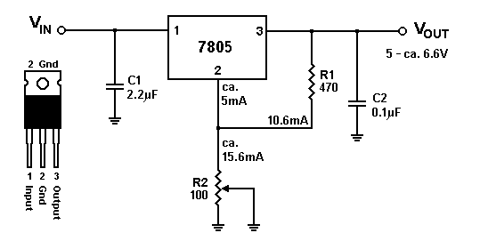

Would you rather run on a +/- 9v supply because you’re using opamps that require a dual supply? Use two 9v batteries that are chained in this way:

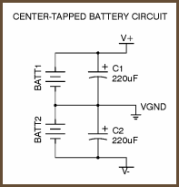

## Community comments about power supplies:

RF says:

my 2 cents -

The CMOS does fine at 5 volts - if you are going to stay all CMOS that would be fine.. 9 is handy if you want to power it from batteries... and a bi-polar supply with 9 volt batteries is easy...

I've used 12 quite a bit - either cause I had the regulators, or because I wanted a + and - 12 volt supply to use with bipolar circuits in the Lunetta. My other equipment used + and - 12 as well. I have not seen any advantage to 15 volts...

Your mileage may vary... 

Rykhaard says:

In my first modular building days in about '92, I went with +/-9V. Coming to wishing for a far more stable power source, I moved to a well regulated Power One +/-15V 1.5 amp supply.

For my noise machine that I started building a year ago February, I started with +/- 9V. Within a month, I tried everything in it, with my +/- 15V supply and it all worked just the same - just with higher otuput voltages. (But it will all still work with +/- 9V as well. And the -9V is only needed in the very few places that have bipolar opamps. The rest runs on the +9.

When I start building things with my PICs, they and everything connected to them will be strictly +5V.

[Rykhaard says:](http://electro-music.com/forum/viewtopic.php?t=42337)

A Legend of sorts, previous to the explanations:

As I've had explained to me in the past, you may think of what's coming out of a battery (or out from the outlet in a house) to power things, as 'water'.

- The SPEED that the 'water' is travelling, is the same as the VOLTS that the source is putting out.

- The AMOUNT of the 'water' that is coming out from the source at that 'speed', is AMPS (or current)

- if you multiply the amount of Volts by the amount of Amps, your answer will give you the amount of WATTS that the supply is. 

## 

## LEDs

Everyone loves blinky lights, and Lunettaheads are no different.  They do represent a bit of an expense though, so the use of them is totally up to you.  I left them out of my machine, but to tell the truth I kind of regret that and wish I had integrated them earlier.  Blinkies are awesome.  They can give you a lot of instant visual feedback about the nature of the signals travelling around your flow.  Consider it!

Remember your resistors for each LED.  Try the superbrights, they pull much less current than the normal ones.  I use the normal ones in mine, they pull about 20mA each where the superbrights pull 2mA.(Sayeth the Ryk)

## Decoupling Capacitors

Each IC that you build into your sound machine will need a decoupling capacitor. This is merely a small value capacitor(I use 103) that is very close to the IC, and connects both to its power and ground pins. This conditions the power supply local to the IC and stabilizes things.

Below is a full explanation of why this is necessary.

**Inputs must be connected to something**

-Pull down resistors

The input pins on these ICs should always connect to something. They need to always be sure of their value, either 0 or 1. Floating (unconnected pins) bring undesirable results.

Any time that you are incorporating a new chip into your setup, have a look at it’s datasheet and identify the input ins. For each input pin take a 100k resistor and connect it to the pin and ground. This will preset the [what?]

up with MANY questions in that direction.  )

Now - on to your questions:

A Diode - in most cases, only allows CURRENT, to travel in 1 direction. (Under normal operation.)

A Resistor - will limit just how MUCH current, is able to travel through that resistor.

A Capacitor - may be thought of as a 'water bucket'. The capacitor when it has a current coming into it, will take in current until the measurable voltage from that capacitor to Ground, is equal to the voltage of that current coming in and filling that capacitor.

Also - a capacitor will BLOCK a DC voltage (Direct Current voltage) - the same current that the capacitor is charging up with. But, a capacitor will allow to pass through it, an AC voltage (Alternating Current voltage)

DC voltage comes from a battery.

AC voltage comes out from the outlet in your wall / walls / etc.

Now - you had mentioned building the 4 x CD40106 oscillators in 1 section, which were all working fine, by themselves.

You had also built 4 x NAND gates around the CD4093 in another section, which would cause PROBLEMS with the 4 x oscillators, when both chips were powered from a single battery! 

Here, we have 4 oscillators. Each of them are turning ON and OFF as each of their Capacitors are filling with current and then emptying themselves of the current. Each of those oscillators are causing draw of current from the battery. EACH of them. They will be causing a little bit of trouble for that poor little CD40106 as each of them oscillates.

As well - when the NAND gates in the CD4093 are switching ON and OFF, they ALSO will be drawing that current.

Each of those 2 chips will be taking away the current that is available FOR them from that single battery.

A solution here (that I wasn't taught until 1991), is add a SMALL capacitor as close as possible to the power INPUT pin, of EACH of those chips. That will help to give each of them a 'reservoir' of current, that they may draw from, when they wish to turn on and off, each of their oscillators.

The mostly standard value of capacitor for hooking up to the Positive Voltage input of each chip is:

0.1 microfarads (uF)

To assist a few chips that may be working together on a circuit board, is also a very good idea to have a larger capacitor, to act as a larger reservoir of current for 'everybody' that is on that circuit board. The greater the amount of chips that are on there, the larger the capacitor we normally use.

For just a few chips, a 10 microfarad capacitor is fine.

For a few more chips, a 47uF or 100uF capacitor will do the job.

## **Pull Down Resistors**

On any of these ICs an essential skill is to be able to look at the datasheet and identify what the inputs are.  CMOS ICs are very picky about this, so All Inputs must be connected to something.  Common practice is to set a default value of 0 on each input using a resistor.  The resistor directs the pin towards ground but also can be overruled by incoming 1s from another source.

Get a mega pack of 100k resistors because you're going to need them (or any value between 15k and 100k will be fine)

Here's a good thread about why pull-down resistors are important:

<http://electro-music.com/forum/viewtopic.php?t=40754>

Another thread with good things to remember

<http://electro-music.com/forum/viewtopic.php?t=42404>

**Top Top** says:  *Don't forget about putting them on your gate inputs!*

**tjookum** says: *Never use anything above 15v!*

*Get your values right, check your resistors and capacitors.*

*Don't switch +V and ground on CMOS chips.*

*Check solder joints and make sure nothing is touching where it shouldn't.*

*You will screw up, relax and try again in the morning.*

## **Oscillators**

Enough talking, let's make some sound.

You'll see oscillators described in two ways.

Audio rate oscillators - These oscillators go high  and low so quickly that we perceive it as a musical tone.  The faster the oscillator the higher the pitch.  They can even go so fast as to be inaudable to the human ear, but your dog is going to be very annoyed with you.  This frequency can be divided to get an octave down effect.

LFOs (Low frequency oscillators)  These oscillators switch on and off at a slower pace than an audio rate osc.  It's slow enough that through a speaker you'll hear the switching as a clicky sound.

LFOs are very useful, they can provide a timing reference, they can switch things on and off, lots of things.

## **DIVIDERS**

<http://electro-music.com/forum/topic-24981.html>

Here's the deal on dividers.  You can input one squarewave and get several in return.  Awesome.

4040 is your friend

<http://www.milkcrate.com.au/_other/sea-moss/#4040>

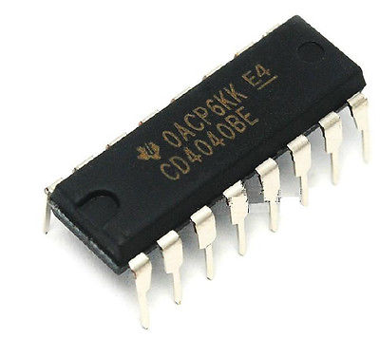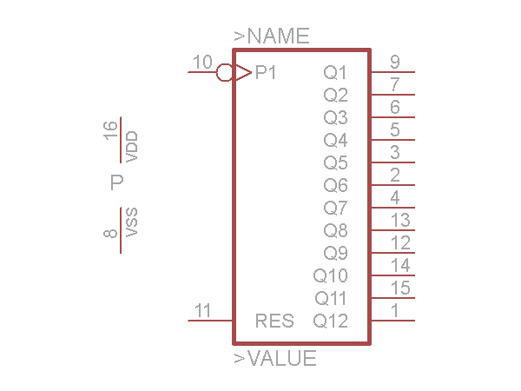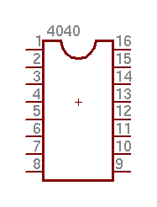

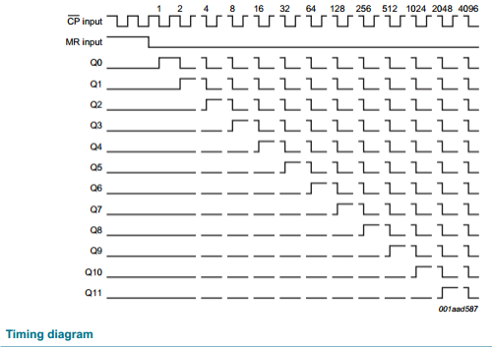

Connect a fast oscillator into the 4040's input, then look at the outputs, perfect divisions of the source frequency, multiplying the amount of signals you can work with

Synchronous vs Ripple counters.

The 4040 a ripple counter, which means that it is asynchronous.

## **Logic Gates**

Logic gates are sort of simple. The output can be only high or low, right? So the logic gate uses conditions to decide when the output is high or low. NAND for example. If either input is low, then the output will be high. So try this, set up an LED at the output of a NAND gate and put two similar but not exactly the same logic oscillators as the inputs (slow ones so you see the action, and make sure your other inputs on the chip go somewhere.) Instead of a regular on/off stream you'll have little stutters of the LED lighting up. That's what we want, to make irregular and unpredictable streams of DATA. Send that through another logic gate and it gets even more irregular and funky.

## **Shift Registers**

**4006**

**4015**

**4024**

Shift registers have two kinds of inputs, Clocks and Data.

Think of clocks as usually regular predictable on/off streams. 1010101 over and over. Any oscillator can be a clock. It sets the timing for the shifting.

Think of Data as less predictable streams of highs and low. instead of 101010101, you can get stuff like 10010111100010010100110101001. See?

So a shift register is like passing a bucket of water down a line of people. The first person passes on a full bucket of water, and it goes down the line of people. Then he passes an empty bucket of water down the line. The clock determines the speed of the passing down the line of outputs, and the data input determines the high or low status being passed down the line of outputs. That's why we need logic gates to make interesting irregular streams of data to pass down the line.

You could up the clocks to audio rates and listen to the shift reg outputs.

Or build the 4051/4017 melody generator and use the shift reg outputs as our A,B,C selectors.

Or send those through resistors(which results in varying analog voltages) into a VCO and listen to them. Any of your oscillators will be good for that, try making a slow oscillator and sending your voltage into the circuit at one of the legs of the potentiometer. The oscillator will wig out, make sure you're listening to it. If that's one of your main logic oscillators then it will flip out, good times good times.

And then your one logic gate output of interesting data gets turned into several outputs of interesting irregular data. LEDs will help visualize what's happening there.

## **PITCH MAKERS**

--------------------------------------------------------------------------------------

<http://electro-music.com/forum/topic-23896.html>

QUOTE MOSC

Once we have little cheap digital oscillators we need to make some pitch patterns.

One of the easiest to use is the modulo-n counter. You can get a 4018 chip that does this function. I don't do building any more so I leave it as an exercise for someone to post the way to set the pinouts.

There is no need to do anything but wire up the 4018 to the banana jacks.

-------------------------------------------------------------------------------------------------

 I think the best way to illustrate this is by building the Slacker Melody generator using the 4017 and the 4051.

## **More Block Ideas**

## **NOISE (white/pink/etc)**

People into modular synths know that noise is a useful thing, particular for percussion synthesis like hi hats and cymbals, or as a component of a snare drum sound.  The topic has come up on the forum about how to achieve this effect using CMOS

---------------------

http://electro-music.com/forum/topic-23939.html

QUOTE MOSC“In a Lunetta, you really don't need noise sources. Just run a few OSCs into a gate modulator and you'll have plenty of nice noise. Whatever gate you use with two audio rate signals gives you a lot of noise - that is a very broad bandwidth signal. Run two sigs like that through another gates and it will be very noisy. But this isn't synthesis like additive or subtractive. This is something rather unique. You would never us a Lunetta to try to make some "sound". You use it to discover sounds that it can do.

”

or connecting the output of two audio rate oscillators into the inputs of a logic gate (NND/AND/OR/XOR).  The output will be noise-like in the manner we want.  If you make two of those noisy outputs and run them into a third logic gate the effect really works nicely.

----------------

**danielwarner** suggests this:

QUOTE “A nice way for getting noisy results out of CMOS like the 40106 is a simple power supply starve pot”

## **Mixers**

http://electro-music.com/forum/topic-23909.html

“It's perfectly OK to build an OP amp analog mixer in your Lunetta. This is especially useful as a final output device.”

# 

****************************************************

***Patching a Lunetta***

****************************************************

A Lunetta Patch is the intentional connection between two or more ICs.

For Example, you would connect one end of a patch cable to the output of an Oscillator, and the other end to the input of a Counter IC, like 4017 decade counter. The outputs of the 4017 might have LEDs attached, and they can also be connected to other ICs.

When making connections on a patchable Lunetta, it would be useful to keep in mind the three basic outcomes of any patch. (Advanced outcomes to follow)

***************************************************

***Possible inputs to a Lunetta Device***

****************************************************

1. Potentiometer - for Osc

2. Data, either self generated or from external (if the grounds are connected)

3. CV, either self generated or from external (if the grounds are connected)

***************************************************

***Possible Outputs from A Lunetta Device***

****************************************************

1. Tones - These are oscillations that are fast enough to be perceived as a musical note.

2. Data - These are signals that are meant to connect to the inputs of ICs with the intention of switching or passing information. Data can be a basic square wave, which is regular and predictable. Data can also be an irregular and unpredictable set of 0s and 1s.

3. CV - Control Voltage of any value between 0volts and the positive power supply. This is intended to control a Voltage Controlled module, like a VCO or VCA. To generate Cv, you need to do a Digital to Analog conversion. This can be done with a DAC IC or with something called a Resistor Ladder(also called R2R) That gets explained later.

4. Clocks - This can be an oscillation of any speed, used to regulate the rate of an IC's activity. Not all ICs need a clock. ICs usually benefit from quite high speed clocks, but you can experiment with any speed you like.

# Your first patches

At this point you should have:

at least two oscillators, either on breadboard or some patchable method, (with LEDs)

A 4040 (with LEDS on the outputs and a pull-down resistor on the input.)

A 4011 (with LEDs on the outputs, and pull-down resistors on the inputs.)

Some kind of amplification to listen to the results, a little lm386 amp would be perfect but anything will do..

### Illustrate each patch, and have a sound clip

# 

### 

# 

# 

# 

# 

# 

# **Moving off the breadboard – and onto panels!**

Process and strategies for creating a more permanent setup

Budget version - breadboard and connector wires, some passives

Stepping up - moving on to panels - cardboard

Stylin' - RF's builds

## **Things to consider when designing a Lunetta:**

connectors- how will you connect blocks together?

-header pins

-banana jacks

-nuts and bolts

Wiring

stranded

single core

ethernet cable (cat5)

ribbon cable

## **Lunetta** Interconnect

by Les Hall

www.electro-music Lunetta Forum

Introduction

The choice of interconnect is a practical, personal, and cost-driven one. In the following text I describe the primary methods of Lunetta interconnect.

sTANg's Method: Banana Jacks

By far the most popular way to do interconnect, banana jacks are fairly inexpensive and they allow you to stack connections so that you can send one output to multiple locations on your Lunetta. sTANg uses them in his sculptures, most notably his cube sculpture which creates very complex sounds. Consider this method if you want medium cost and ease of patching. A true Lunetta purist will go for this alternative if only to honor sTANg's legacy, however there are other options to consider so read on.

Nuts and Bolts

A very inexpensive method of interconnect is to use connect your circuits with nuts and bolts. For wires you use alligator clips on either end of each wire and protruding from your synth are the ends of bolts. This method saves space and breaks the cost barrier as well. Consider it to be your choice if you want low cost and the ability to make lots of connections per terminal.

Wires

If you're breadboarding the circuit, then all you need is 24 gauge solid wire to hook things up.

Screw Terminals

One very compact way to do interconnect is to use screw terminals. You can get 0.1" spacing screw terminals that hold up to two or three 24 gauge solid wires per terminal for about $0.40 per terminal from suppliers such as www.digikey.com and others. This is a fairly pricey alternative, and you would only choose it in situations where space is a premium or for doing sculptures. The screw terminals require that you have a really tiny slotted screwdriver to make the connections. I feel that this method is best suited for situations like patching on a Lunetta PCB and not for entire systems like a Lunetta modular.

Conclusion

There are a few different methods of doing interconnect for Lunettas so the choice is up to you. Naturally you will want to select the best alternative for your situation.

## Lunetta Construction Methods

by Les Hall

www.electro-music.com Lunetta Forum

Introduction

There are several ways to construct your Lunetta circuits, each with their own advantages and disadvantages. Depending on your budget and building skills, you may wish to use any of the techniques described below or more likely a combination of them.

Stanley Lunetta's Construction Method

Our Lunetta founder, sTANg, tells us that his preferred construction technique is to glue the chips upside down onto a flat panel (or curved panel in some cases), and solder wires directly to the chip leads. Some advantages to this technique include low cost, simplicity, ease of construction, and practicality when creating sculptures which is one of sTANg's specialties. Disadvantages include difficulty in repairing damaged chips and the requirement of some slightly tricky soldering. Since this method is the basis of sTANg's work, a true Lunetta purist will want to at least give it a try just for fun - recommended!

Modular Synthesizer Construction Method

By far the most popular technique, this method involves cutting and drilling panels of metal or some other flat material in much the same way as is done with modular synthesizers. Once cut to size and drilled with mounting holes, the panels are held in a rack or suitcase enclosure with mounting hardware such as screws or nuts and bolts. Then the builder drills holes in the panel for attaching potentiometers, switches, and banana jacks. The circuitry behind each panel is then constructed on a small prototyping circuit board, attached to the back of the panel, and then wires establish connections between the circuitry and the parts mounted in the panels.

Advantages of the modular synthesizer construction method include the elegance and functionality of construction and the ability to patch modules using essentially the same system as high quality modular synthesizers. If a suitcase or other portable enclosure holds the circuitry, then the system is nicely portable as well. Disadvantages include higher cost than other construction methods and the requirement of mechanical fabrication. If you want to patch your Lunetta circuits together in the same way as done with expensive, high quality modular synthesizers then this is the construction method for you.

Breadboard Construction Method

This technique is best suited for quickly and easily testing Lunetta circuit ideas. Breadboarded circuits require little soldering and no banana jacks or panel mount potentiometers and switches. Instead, stripped wires do the patching and all other interconnect required, and small thru-hole PCB mount parts such as thumbwheel potentiometers provide convenience and the ability to rapidly prototype Lunetta circuits. The primary disadvantage of this technique is the cost of the breadboards, so usually the circuits are temporarily built this way for testing purposes and then the designer transfers the components to a more permanent and less costly form.

Open Sculpture Construction Method

If you have good soldering skills, you may wish to build free-form sculptures of circuitry using solid wire to establish the interconnection. This is a very artistic method, with completed sculptures having a three-dimensional appearance. Advantages of this technique include beauty of the finished project and very low cost. Disadvantages include time of assembly, fragility especially in transport, and difficulty of repair.

Printed Circuit Board Construction Method

If the Lunetta circuit designer chooses to create multiple copies of the circuit design then a PCB may be the best option. Once the PCB design is fully tested and debugged, the designer can have a professional board house produce as many circuit boards as desired. For smaller PCB runs, in-home circuit board etching may be a good alternative as well.

Conclusion

The construction method that you select is a personal choice depending on your budget and skill set, as well as your available time. I recommend beginning with a single breadboard and building various simple circuits on it, then graduating to one of the other techniques according to your preference. No matter what construction method you use, your Lunetta circuits will work essentially the same. Good luck, and happy building!

## How to Connect Lunetta Modules

Check this valuable thread out.:  <http://electro-music.com/forum/viewtopic.php?t=42337>

**I quoteth the Rykhaard:**

Now - as to CMOS chip INPUTS. These little buggers can be fussy chips when they have Inputs that have NOTHING hooked up to them. It is best to always, hook up those inputs, - IF they are unused - to +V (positive voltage) or to Ground. This is dependant on what the function of each of those inputs IS.

When you are having inputs that DO have something hooked up to them, it is a standard practice in music electronics to give the inputs a 100,000 ohm impedance. 1 end of the 100k resistor (1/4 watt - is the standard size), can be hooked up directly to the input and the other end can be hooked up to the input connection to that chip's input.

Another way to do it, is to run the 100k resistor from the input pin to Ground and then the input connection for that chip's pin, to the junction of the 100k resistor and that chip's input pin.

(There are further explanations relevant to that, but for the moment I'll just leave it at that - as I've been explaining a few things already and don't wish to dump too much down on you at 1 time.  )

Finally - as to Outputs, it has been standard practice since about the mid 1970's, to put a 1,000 ohm 1/4 watt resistor on to the output pin from the chip. This is handy especially, if the Output is ever accidentally SHORTED to somewhere else, that output will only allow:

The Output Voltage DIVIDED by the Output Resistor's ohm rating amount of CURRENT, to short to wherever it is going.

Now that SHORT - will be pulling that MUCH current out of that chip! And that chip, without that protecting output resistor, may _NOT_ be very happy at all. 

And now, REALLY, finally  - that formula that I just dropped into your mental lap, is probably 1 of THEE most important formulas in electronics to memorize and become familiar with - Ohm's Law. To calculate it, we use the following specifications:

voltage = Volts as in a 9 volt battery = 9 volts

resistance = Ohms as in a 1,000 ohm (1k) resistor

current = Amps

Ohms law = :

VOLTS (V) divided by CURRENT (I) multiplied by OHMS (R)

or

VOLTS (V) = CURRENT (I) multiplied by OHMS (R)

CURRENT (I) = VOLTAGE (V) divided by OHMS (R)

OHMS (R) = VOLTS (V) divided by CURRENT (I)

Symbolically:

|  |
| --- |
| **Code:** |
| V  -----  I * R |

[/code]

And there we are for now, class.  Aye. There is another new chap that has become interest in Lunetta building as well. Any of you could begin your own beginner's threads, or you could join in with someone’s (which collectively, may be better for informational organization.) That's up to yourself and where you feel most comfortable. 

# 

# 

# Hooking up to your sound card with a Capacitor:

Here's a good discussion on how you can protect your soundcard by using a capacitor to block DC voltage from your Lunetta.  You never know when a power short could happen so it's good to take care of your gear.

<http://electro-music.com/forum/viewtopic.php?t=32668>

*QUOTING MOSC FROM THE THREAD*

""Most probably it is safe; one won't damage your sound card or amplifier by plugging in your Lunetta, but you never know. There are all kinds of protection circuits one can use, but the simplest one is a single capacitor that is connected in series between the Lunetta and whatever you are using.

A single cap in series with an signal is known as a **DC blocker**. It's also known as **AC Coupling**. So if your Lunetta for some reason has some DC component that might damage your gear, the single cap will keep it on the Lunetta side of the street, so to speak.

What size? You can experiment but 0.1 uF is a good starting place. The bigger the cap, the less low frequency attenuation.

[EDIT - Corrected error - should be microFarads.]

Of course if you are using a Lunetta to generate CVs to go to other analog gear, then the cap is going to defeat that. Here's the dilemma; most commercial sound gear is AC coupled on the inputs, so your added AC coupling on the output isn't going to add more protection - **but it will not hurt either**. Your modular analog synth gear is DC coupled because of the needs to handle DC level control voltages. Most synth circuits don't provide over voltage protection, because they assume their CV inputs are coming from within their own system or are in safe bounds already.

So, if you are using your Lunetta to drive CVs, then just make sure you never exceed the capabilities of whatever it is you are driving. There are over voltage protection circuits you can use, but that's for another topic, unless someone want's to post them here. ""

# 

# 

# **Getting advanced,**

## **The Slacker Melody Ge**nerator

This is a special module that deserves to be hard-wired as its own module in your system.  It uses two chips, the 4017 decade counter and the 4051 multiplexor.

- Inputs -

1 audio rate clock.  that's just a square wave that's fast enough to be perceived to be a musical tone.

3 slower logic clocks (data) - these should be somewhat irregular streams of 1s and 0s, slower than audio rate, maybe about half a second between changes at first.

-the setup-

4017 is the IC that actually changes the notes that you're going to be hearing.  It does this by dividing the audio rate clock.  The divisions are different depending on which of its outputs are sent back into the reset pin.So connect 8 of the 4017 outputs to the 8 inputs on the 4051.

4051 is the IC that we're going to use as a router to choose which of the 4017 outputs is going to be sent back into the 4017's reset pin.

The 3 slow clocks (low frequency oscillators) are applied to the 'select A,B,C' pins of the 4051, this tells it which of the several input signals gets routed to the one output on the 4051.

-Output-

The first output of the 4017 is the audio output that will be sent to the amp or mixer.

## 

## My standard starting point:

## 

## **the R/2R DAC**

RF has given some good info on those R/2R ladders, plug logic outputs into the inputs, these have six inputs, and out comes a varying voltage, which you then send to a voltage controlled oscillator

## **Interfacing with other devices.**

-fun with 4066

-make sure the grounds are connected

# **Stand alone projects that are Lunetta Friendly**

## **NAND synth**

This is a sound machine based on the 4093 chip, which has 4 schmitt trigger NAND gates on it.

## 

## 

## **WSG**

<http://musicfromouterspace.com/analogsynth/YOUR_FIRST_SYNTH/WSG_Reborn/WEIRDSOUNDGENERATORREBORN.php?page=WSG>

Ray Wilson has created the ultimate beginners project that is very friendly with the things we're talking about here.  6 oscillators based on the 40106 and an awesome lowpass filter designed around a 741 op amp.  The filter is so good and simple to construct that people often use that portion of the circuit in other projects.

# **Here's the thread that started it all.**

[Stanley Lunetta](http://electro-music.com/forum/topic-23215.html)

<http://electro-music.com/forum/topic-23215.html>

# 

# 

# Larger **Projects to make (Let's DO THIS):**

Project plans:

## **1. Lunetta in the style of a modular synthesizers**

## **2. Single Board Lunetta**

3. Electri-Fire's designs

http://electro-music.com/forum/viewtopic.php?t=38634

## **4. Les Hall's Boolean Sequencer**

Boolean Sequencer Tutorial

by Les Hall

www.electro-music.com Lunetta Forum

<http://electro-music.com/forum/viewtopic.php?t=38163&start=25>

[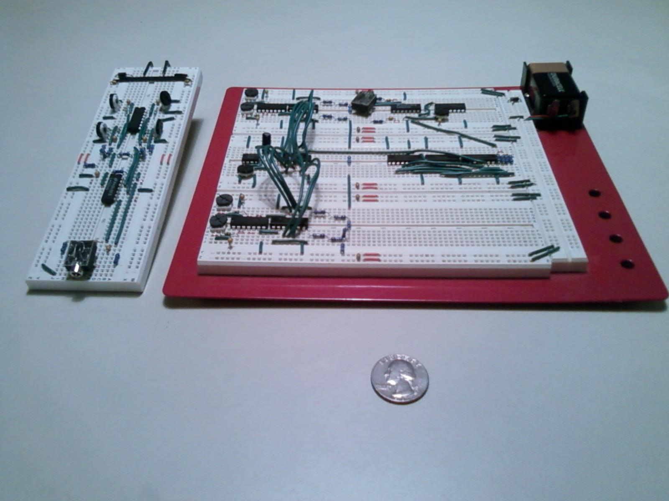](http://electro-music.com/forum/viewtopic.php?t=38163&start=25)

(errata: "  And as I mentioned to droffset in the chat room last night, a correction to the doc is that the input clock must be at twice the note rate, not once per note, so it would be 8Hz not 4Hz. ")

One way to get some really cool sounds from a Lunetta circuit is to build a Boolean Sequencer. I created the concept of the Boolean Sequencer myself and people tell me that it is a new concept, however I like to say that I reinvented it rather than invented it because it has existed in various forms for many years. Here's how it works.

First, make an LFO clock signal of your choice. This clock is usually of a constant frequency, though you could vary the frequency over time if you like. The notes produced by the Boolean Sequencer will normally occur once per clock cycle, so if you like 4/4 timing then make the clock be 4Hz.

Second, send your clock into a CD4040 binary counter chip. You'll want to use a pulldown resistor of any value from 20k to 1Meg on the reset input so that the counter will actually count.

Third, add some logic chips like AND gates or XOR gates and connect the inputs of the logic gates to the output bits of the CD4040 chip. You can use any type of logic you prefer and you can add as many layers of logic as you like. This is where the creativity of the Boolean Sequencer comes into play because the logic that you set up will determine the sequence of notes that you get.

Fourth, use a passive component network such as an R2R ladder or a voltage summation circuit to combine the outputs of the logic that you created into an analog signal.

Fifth, buffer the signal with a voltage follower using an op-amp chip such as a TL074. Drive this into a VCO made from a CD40106 oscillator, then buffer the VCO output with another voltage follower and send it out to a jack with a DC blocking cap and a 1k resistor in series. This will enable you to drive the output signal into a pair of amplified speakers or into the line-in jack of a computer for example.

OK that's a lot to understand, so I'll explain some more about the Boolean Sequencer. Unlike many other sequencers, the Boolean Sequencer can produce very long sequences of notes. Normally you have 8 or 10 or 16 steps in a step sequencer, however a Boolean Sequencer can produce a huge number of steps. You can create any binary number of steps such as 256 steps or 4096 steps or whatever, though you can make the sequence be any number of steps by playing a little reset trick.

The CD4040 has a 12 bit output count, which is 4096 unique output states. If you were to make use of all 12 bits as input to your logic, then you would get a 4096 step sequence. To put that into context, at four quarter timing (four notes per second) a 4096 step sequence will last for 1024 seconds. That's 17 minutes of continuous music before the pattern repeats.

In addition to the long sequences, a Boolean Sequencer will often produce repeating patterns of notes, or phrases, that change a little bit as they occur. These phrases are typically a binary number of steps as well. Yet another curious aspect of the Boolean Sequencer is that it will often produce moments of silence mixed in with the notes. This occasional silence can add a dramatic element to your music. In practice I have found that using a sum of products logic network causes lots of dramatic gaps, while using XOR gates generally produces no gaps at all.

As an example I will describe one Boolean Sequencer that makes nice sequences and great sounds. Start with a LMC555 timer or a CD40106 inverter and send that into a CD4040 binary counter. Then add a CD4030 quad two-input XOR chip and connect the outputs of the CD4040 chip to the inputs of the XOR gates. Next connect the four outputs of the CD4030 chip to four resistors and connect the other end of the resistors together. Send the combined signal into a TL074 quad op-amp or any suitable op-amp to buffer the signal. This buffers the signal so that you can do the next step, which is create a CD40106 oscillator and connect the output of the op-amp to the power supply pin of the CD40106 chip. Use another one of the op-amps on the TL074 chip to buffer the CD40106 oscillator's output and you're done.

In summary you do this: LMC555 LFO => CD4040 binary counter => CD4030 XOR => resistor summation network => TL074 op-amp => CD40106 oscillator => another TL074 op-amp => listening device.

This is a little bit complicated as it involves five chips, but that's OK because it produces really cool sounds. Here is what is happening in the circuit: The LFO clocks the CD4040 at the desired note rate, the CD4040 produces a binary count, The CD4030 establishes the sequence of notes, the resistor network creates a stepped analog control voltage (CV) signal, and the TL074 along with the CD40106 serve as a voltage controlled oscillator (VCO). Clear as mud? Good! Now go build one for yourself!

# **Lunettas and your modular synthesizer**

type here

# **Where to go from here?**

type here

# 

# 

# **Resources and credits**

## **The most helpful link in the world.**

Ok, maybe not THE MOST, there might be better, but for visual learners like me this has been invaluable.  Make sure java is installed on your computer, and be sure to dig through the menus to see the logic examples.

<http://falstad.com/circuit/>

## **Good Books**

CMOS cookbook

Nic Collins Hardware hacking

50 CMOS IC projects - RA Penfold

## **CMOS IC info**

<http://www.qsl.net/yo5ofh/data_sheets/>

<http://www.kpsec.freeuk.com/components/cmos.htm>

<http://en.wikipedia.org/wiki/4000_series>

<http://dropmix.xs4all.nl/pipermail/synth-diy/>

Intro to CMOS 4011 IC

<http://www.zen22142.zen.co.uk/ronj/cm11.html>

# 

# 

# Other info

About musical notation from this thread:    <http://electro-music.com/forum/viewtopic.php?t=40243>

""""""""""""""""""""""""

QUOTING ELECTRI-FIRE

"""""""""""""""""""

In musical notation, a bar (or measure) is a segment of time defined as a given number of beats of a given duration.

<http://en.wikipedia.org/wiki/Bar_>(music)

The time signature (also known as meter signature) specifies how many beats are in each measure and which note value constitutes one beat.

Simple time signatures consist of two numerals, one stacked above the other:

the lower numeral indicates the note value which represents one beat (the "beat unit");

the upper numeral indicates how many such beats there are in a bar.

<http://en.wikipedia.org/wiki/Time_signatures>

The tempo of a piece will typically be written at the start of a piece of music, and in modern music is usually indicated in beats per minute (BPM).

<http://en.wikipedia.org/wiki/Tempo>

To set tempo, you need to change the speed of the clock LFO. A fixed speed of 4 Hz has a BPM of 240 (120BPM after the 4040 has divided by 2 at minimum, as Droffset pointed out).

Barlines in musical notation are a means to organize/ facilitate the reading of music, but it is artificial, ermm.. fiction. The actual notes just continue, and you could divide a piece of music into bars of any length without changing the music when played.

If you play the same piece faster, more notes (beats) will be played during a minute, thus you have a higher BPM.

So to play more notes in a minute with your sequencer you increase the speed of the clock LFO.

""""""""""

The only thing about the 4040(my favorite) that worries me is the asynchronous outputs that a ripple counter brings, but it does add some expression to the note changes. I like the idea of 4017 based dividers that give really nice synchronous /2 /3 /4 /5 etc divisions but haven't built one yet.

About beats and measures all I can add is that there's a reason we see more 8 and 16 step sequencers than 10 step ones, because a lot of music is based on 4 beats per measure. If you count the beats in music some repetition of a musical phrase will normally occur, for example:

<http://www.youtube.com/watch?v=0epDXa6hsJg>

Bass drum is on 1 and 3, snare is on 2 and 4.

1234

1234

1234

1234

Waltz music is 3/4, so if you count along with the music it'll go

123

123

123

123

<http://www.youtube.com/watch?v=Ob6TTU1knUM>

# 

# 

# **Contact me:**

I need feedback and suggestions.  I'd also appreciate fully typed out contributions and illustrations!

My name is Sergio

My email address is droffset13@gmail.com

Check out my blog at http://droffset.blogspot.com

Twitter @droffset

Disclaimer - This is a work in progress and could be edited at any time.  I do this for free and for the benefit of anyone visiting [Electro-music.com](http://electro-music.com/) because they have been very helpful and friendly in my search for fun and knowledge.  I've tried my best to give credit to all of the people who created the ideas and images contained here but if you see your work or links to your work here and want it deleted let me know and it'll get fixed.  There's no need to pay for this info, but if you'd like to donate ICs or any toys to circuit bend I'd be very happy to accept them.  So­ here it is!